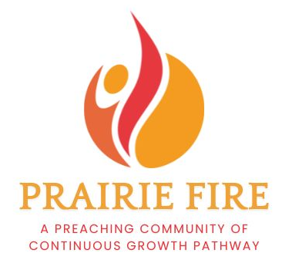
PRAIRIE FIRE PREACHING COMMUNITY
REFERENCE: Council Member or Equivalent Person from your current call
Name
Role
Cell Phone
Email
Please keep each answer below to 500 words or less.
1. Investing in preaching requires time and energy. Participants are expected to attend all retreats (Oct 27-29, 2025; Jan 12-14, 2026; May 18-20, 2026; Aug 17-19, 2026) and monthly Zoom cohort gatherings between retreats. How will your leadership support the applicant in their participation in Prairie Fire?

2. How might their participation in this experience benefit your congregation or organization?

