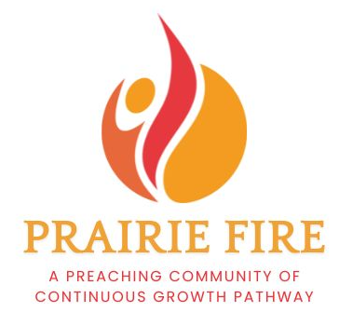

**PRAIRIE FIRE PREACHING COMMUNITY APPLICATION**

Name

Address

Cell Phone

Email

Name(s) and address of current call/context you are serving:

**Please keep each answer below to 500 words or less.**

1. Why are you applying for the Prairie Fire Preaching Community? How do you hope this experience will make a difference in your preaching?

2. Describe your current context of preaching. What is your role? How often do you preach? Which lectionary series do you use, if any? How will this experience make a difference for your community/context?

3. Investing in preaching requires time and energy. Participants are expected to attend all retreats (Oct 27-29, 2025; Jan 12-14, 2026; May 18-20, 2026; Aug 17-19, 2026) and monthly Zoom cohort gatherings between retreats. How will you make time to be part of this preaching community?

4. What is one aspect of preaching you want to explore, grow in, improve or try?

5. Is there anything else you would like us to know?

**REFERENCES**

**Reference from a Colleague in Ministry**  
Accountability and collegiality are key values in building this Prairie Fire community.

Please share contact information of someone who can serve as a reference for you as a colleague in ministry.

Name

Context they serve

Phone

Email

**Reference from a council member or equivalent person** Please include a completed reference from a council member or equivalent leader as part of your application. The reference form can be found at <http://www.cgpmn.org/prairiefire>.

**Submit your application and reference by March 1, 2025 to**: Pastor Laura Aase, Assistant Director Continuous Growth Pathway aase@gustavus.edu

Thank you for your interest in the Prairie Fire Preaching Community.

The 2025-2026 cohorts will be selected by May 2025. All applicants will be notified at that time.

For questions or additional information, contact:

***Pastor Laura Aase,*** Assistant Director Continuous Growth Pathway aase@gustavus.edu 651-788-0868